An integrated fission gas swelling correlation for UMo research reactor fuel

Benjamin Beeler, Bei Ye, Jahid Hasan, Zhi-Gang Mei, Hakan Ozaltun

A mechanistic, microstructure-based approach has the potential to provide a more predictive fuel performance capability than empirical fitting to limited experimental datasets. This is particularly the case when data is restricted to certain operating parameters, but the materials of interest may operate outside of that experimental phase space. By incorporating lower length scale (LLS) information, e.g. experimental microstructures, atomistic information, e.g. diffusivities, and LLS modeling information, e.g. bubble evolution, a more general model can be developed that appropriately incorporates underlying physical phenomena into macroscale predictions. This work aims to begin introducing LLS information into the fission gas swelling models that can be implemented in the engineering scale fuel performance modeling simulations.

## Fitting Procedure

Modification of the fission gas swelling is performed to include the initial grain size, fission rate density, temperature, and fission density. This allows for three additional levels of detail beyond the pre-existing correlations, which are only function of the fission density. In order to account for the additional levels of information, underlying data needs to be obtained that can be utilized to fit various descriptive functions. Thus, the DART (Ye et al., 2013) code was utilized to investigate variability of each of the respective quantities of interest, sufficient to gain quantitative trends. Fission densities at 136 increments are reported for each configuration, up to a maximum fission density of approximately $7×{10}^{21}$ fiss/cm3. Three grain sizes (4.4 mm, 8.5 mm, and 17 mm) are investigated to gain a sense of variability with initial grain size. Three fission rate densities ( $3.0×{10}^{14}$ fiss/cm3-s, fiss/cm3-s, and fiss/cm3-s) were implemented to quantify the effects of fission rate density, assuming a constant fission rate density throughout the entire lifetime. Two temperatures (defined as the initial full power centerline temperature) were also studied (150°C and 115°C) to generate a temperature dependence. The nominal parameters were chosen to be 8.5 mm, fiss/cm3-s, and 150°C. These are reasonable parameters, although the exact conditions for each relevant research reactor will be slightly different. It should be noted that although the data sets under investigation are not wholly inclusive with respect to the potential set of conditions in research reactors of interest, the generated functions are expected to be accurate under minimal extrapolation.

The existing fuel swelling correlations are shown below in . Further detail on each of these individual correlations can be found in (Robinson et al., 2021). One key aspect of note of all these models is the piece-wise nature, splitting low fission density behavior from high fission density. This is due to the more rapid swelling after grain refinement starts to occur. Generally, a transition occurs at a fission density of $3×{10}^{21}$ fiss/cm3. A similar approach is taken here, although instead of a piecewise function, an addition of two functions is employed with an analytical Heaviside step function to effectively negative one of the functions below a certain fission density. Unlike the previous correlations, the point at which the Heaviside function switches, and the steepness of the transfer, are fitting parameters, providing additional flexibility to accommodate the data set.

Figure . Fuel swelling as a function of fission density. Reproduced from (Robinson et al., 2021).

After initial analysis of the fission gas swelling data from DART, the below functional forms were implemented:

|  |  |
| --- | --- |
| $$FGS\%= \left[f_{1}\left(f_{d},D\right) + f_{2}(f_{d},D)\right]{×f}_{c}\left(f_{d}\right)×f_{3}(\dot{f})×f_{4}(T)$$ | 1 |

where $f_{d}$ is the fission density, $D$ is the initial grain size, $\dot{f}$ is the fission rate density, and $T$ is the temperature.

The function $f_{1}$, $f_{2}$, and $f_{c}$ are defined as:

|  |  |  |  |
| --- | --- | --- | --- |
| $$f_{1}=\frac{a×D^{b}}{1+\exp\left(-\left(c×D^{d}\right)×\left(f_{d}-\left(e×D^{f}\right)\right)\right)}$$ | | 2 | |
|  | | 3 | |
|  | | 4 | |

where the coefficients *a* through *m* are fitting parameters. The denominator in both $f_{1}$ and $f_{2}$ operate as the Heaviside step function. The cutoff function, $f_{c}$, enforces that as the fission density approaches zero, the swelling approaches zero.

The fitting procedure is undertaken to minimize the sum of the squares of the residuals for each data point. An initially null (all zeros) guess is provided, and a random step is given to each parameter. The total error against all data points (408 data points, 136 for each grain size) is compared to the error at the previous step, and the new coefficients are saved if the error is reduced. If the error is increased due to the new coefficients, a probability function based upon the difference between the previous error and the current error is employed ($P=exp⁡(-10×∆err)$) to allow more flexibility in the evolution of coefficients. An R2 value of greater than 0.99 is achieved in the fitting process, with the corresponding coefficients provided in .

Table 1. Fitting coefficients for the fission gas swelling as a function of grain size and fission density.

|  |  |
| --- | --- |
| Coefficient | Value |
| a | 14.55352 |
| b | -0.13102 |
| c | 3.18009 |
| d | -0.45099 |
| e | 3.51274 |
| f | 0.23686 |
| g | 16.1437 |
| h | 15.87839 |
| j | 3.18205 |
| k | -0.92817 |
| l | 0.69424 |
| m | 1.17983 |

The fission rate density dependence is a second order polynomial, given by:

|  |  |
| --- | --- |
| $$f_{3}=7.345×{10}^{-31}×{\dot{f}}^{2}+3.598 ×\dot{f}+0.527$$ | 5 |

where $\dot{f}$ is provided in units of fiss/cm3-s, and the temperature dependence is a linear function:

|  |  |
| --- | --- |
| $$f_{4}=0.0088×T-0.3235$$ | 6 |
| where the temperature is provided in degrees Celsius. |  |

## Results

An example of the fission gas swelling as a function of fission density for three different grain sizes is shown in , where the grain sizes are shown in the legend and provided in units of *µ*m. The 8.5 *µ*m case is considered the nominal case. As can be seen, a smaller grain size leads to more rapid swelling and a larger total swelling at the end of life. Conversely, larger grain size leads to a more gradual swelling behavior. This corresponds to previous computational phase-field work (Beeler et al., 2020).

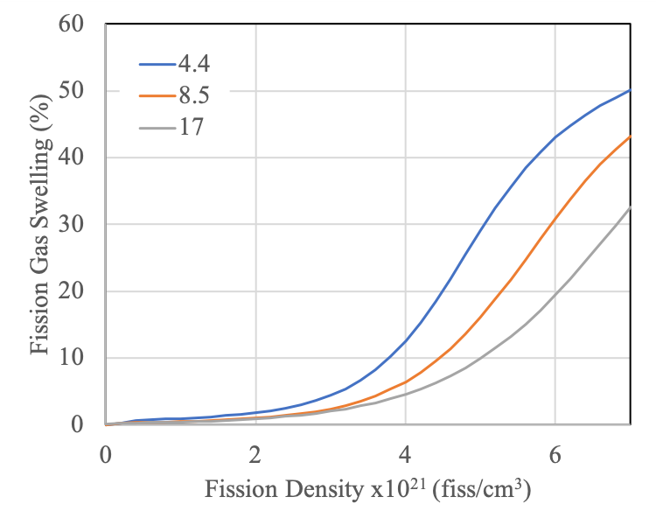

Figure . Fission gas swelling as a function of fission density at three unique grain sizes. increase in the fission rate density, at the same fission density, tends to increase the amount of swelling. The data shown is for the 4.4 µm grain size.

An example of the effect of fission rate density is shown in , where the fission gas swelling as a function of fission density at three fission rate densities is shown. This is for the case of a grain size of 4.4 *µ*m. As would be expected, an increase in the fission rate density yields a corresponding increase in the fission gas swelling. This is believed to be largely due to the corresponding increase in the temperature that is associated with an increased fission rate density. Currently there is no grain size dependence on the fission rate dependence, but such additional complexity will be included in the future.

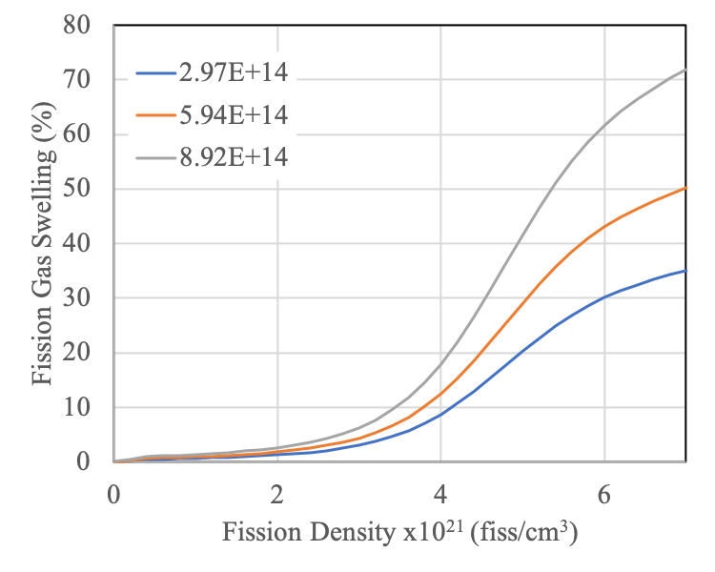

Figure . Fission gas swelling as a function of fission density at three unique fission rate densities.

The temperature dependence itself is shown in , for a grain size of 4.4 *µ*m and a fission rate density of $5.9×{10}^{14}$ fiss/cm3-s. Higher temperatures indeed lead to accelerated swelling behaviors. Currently there is no grain size dependence on the temperature dependence, but such additional complexity will be included in the future.



Figure . The fission gas swelling as a function of fission density at three unique temperatures.

## Discussion

A comparison of the Robinson (Robinson et al., 2021) swelling correlation to the fission gas swelling predictions from the current work is shown in . This chart assumes the nominal fission rate density and nominal initial centerline temperature. For the nominal grain size (8.5 mm), this work reasonably accurately reproduces the fission gas swelling data from Robinson. It should be emphasized that the Robinson correlation and the experimental data on which it was built were NOT utilized as inputs into this model, but only LLS modeling fission gas swelling predictions from DART were utilized. Given the lack of information on nominal grain size in UMo monolithic fuel and the assumption of a nominal grain size, this is considered excellent agreement with the experimental correlations. Provided potential modifications in the fabrication process produce corresponding changes in the initial grain structures, we are showing that sufficiently large deviations from the existing nominal grain morphology can produce significant (30%) over- or under-predictions on the end-of-life fuel swelling. As more information on the initial grain microstructures are provided, these models can be modified to incorporate the true nominal grain size, and potentially information on grain size distributions, to more fully describe the evolution of fission gas swelling as a function of fission density. This refinement of how the nominal case is defined can also be modified for the fission rate density and the temperature.

Another key finding from this work that is not currently captured in the Robinson correlation is the importance of temperature. A thirty-degree difference in the initial centerline temperature can affect a 15% change in the fission gas swelling at the end-of-life. Given that different research reactors possess different operating conditions, including inlet temperature which would affect fuel centerline temperature, including variability of swelling with temperature appears to be critical.



Figure . The fission gas swelling as a function of fission density, comparing the previous gaseous swelling correlation to four grain sizes from the present work. Legend units in mm.

## Conclusions

An updated fission gas swelling model was generated that incorporates grain size, temperature, fission rate density, and fission density for UMo monolithic fuel. For the assumed nominal case, the swelling correlation presented here reasonably reproduces the experimentally based swelling correlations. This work has defined functional relationships relating the individual state variables of interest to the fission gas swelling, allowing for exploration of operational phase spaces that are not able to be described by the existing experimental correlations. This work has highlighted the need to understand the initial microstructure of UMo monolithic fuel, as modifications in initial grain size can yield substantially different results in the fission gas swelling behavior.

This model has been delivered to the engineering fuel performance modeling team and is currently undergoing evaluation.